

**Lab Assignment-1**

**Name: Somit Jain**

**Reg No: 20BDS0181**

**Course Code: CSE2015**

**Internet Programming and Web Technologies**

**Slot: L45+L46**

**Professor: Dr. LOKESH KUMAR R**

**Class ID: VL2022230504175**

[**GITHUB LINK**](https://github.com/somit-27/Internet-Programming-and-Web-Technologies/tree/master/Activity-1)

**CODE:**

**MAIN PAGE:**

<html>

    <head>

        <title>Actvity-1</title>

        <link rel="stylesheet" href="Style1.css">

    </head>

    <body>

        <h1 style="text-align:center">Somit Jain</h1>

        <div id="subs">

            <a id="sub" href="SubscriptionForm.html">Subscribe to my blog</a>

        </div>

        <br>

        <div id="me">

            <h3 id="about">--About Me--</h3>

            My name is Somit Jain. I am 20 years old. I am a pre final year student in <b>Vellore Institute of Technology, Vellore</b> pursuing B.Tech in <b>Computer Science with specialisation in Data Science</b>. I like to watch <b>Formula 1</b> and <b>Football</b>.

             I currently live in <b>Mumbai, Maharashtra</b>.

            <br>

        <div id="course">

            <h3>--Courses I am studying in Winter Sem 2022--</h3>

            <ol id="courselist">

                <li>Internet Programming and Web Technologies</li>

                <li>Data Visualization and Presentation</li>

                <li>Information Retrieval and Extraction</li>

                <li>Espanol Fundamental</li>

                <li>Natural Language Processing</li>

                <li>Infomration Security Management</li>

                <li>LSM</li>

                <li>TARP</li>

                <li>Soft Skills</li>

            </ol>

        </div>

        <div id="fav">

            <ol>

                <b id="tt">--Favourite Movies--</b>

                <li><a href="https://marvelcinematicuniverse.fandom.com/wiki/Avengers:_Infinity_War">Avengers: Infinity War</a></li>

                <li><a href="https://www.netflix.com/title/80196613">12 strong</a></li>

                <li><a href="https://en.wikipedia.org/wiki/Pirates_of_the_Caribbean_(film_series)">Pirates Of The Carribean</a></li>

            </ol>

            <ol>

                <b id="tt">--Favourite TV Shows--</b>

                <li><a href="https://www.hbo.com/house-of-the-dragon">House of the Dragon</a></li>

                <li><a href="https://www.imdb.com/title/tt0898266/">The Big Bang Theory</a></li>

                <li><a href="https://www.rottentomatoes.com/tv/the_office">The Office</a></li>

            </ol>

        </div>

        <div id="col1">

            <img src="gaming.jpg" alt="happy" id="happy">

        </div>

        <div id="col2">

            <img src="headphones.png" alt="sad" id="sad">

        </div>

        <br clear="all">

        <div class="titles">

                <h3 id="tag">Happy_Photo Sad_Photo</h3>

        </div>

        </div>

        <br clear="all">

        <br>

        <div>

            <h3 id="fact">--Interesting facts about COVID in Maharashtra--</h3>

            <img src="covid.png" alt="covid" id="covid" usemap="#image-map">

            <map name="image-map">

                <area target="_blank" alt="Konkan Region" title="Konkan Region" href="http://divcomkonkan.gov.in/Document/en/page/MapGallery.aspx" coords="59,237,39,116,40,235,20,126,46,179,31,180,23,155,37,149,31,207,49,203,21,103,35,96,25,167,50,243" shape="poly">

                <area target="_blank" alt="Pune Region" title="Pune Region" href="https://www.mapsofindia.com/maps/maharashtra/districts/pune.htm" coords="56,110,66,119,75,129,85,142,98,143,108,144,112,151,125,147,130,165,142,172,151,175,144,188,127,184,123,202,123,202,103,203,91,208,78,212,67,219,75,231,69,243,59,235,52,211,48,199,47,175,41,157,37,142,38,126,44,115" shape="poly">

                <area target="_blank" alt="Nashik Region" title="Nashik Region" href="https://nashik.gov.in/about-district/#:~:text=Nashik%20is%20an%20ancient%20city,is%20held%20every%2012%20years." coords="88,78,97,71,110,66,134,61,138,47,138,33,116,27,101,29,87,20,80,11,64,8,52,19,55,32,55,43,50,59,40,62,34,75,38,91,49,106,63,112,74,128,82,138,94,142,106,140,114,135,91,126,98,118,111,116,110,104,89,98,79,87" shape="poly">

                <area target="_blank" alt="Aurangabad Region" title="Aurangabad Region" href="https://en.wikipedia.org/wiki/Aurangabad" coords="85,81,93,76,111,67,126,62,132,69,139,80,145,88,145,94,140,110,152,122,165,130,192,98,205,103,217,98,206,89,225,90,214,112,203,118,203,132,190,149,175,153,168,161,160,170,146,170,132,164,118,144,107,141,114,130,93,125,112,116,112,103,89,98,81,89" shape="poly">

                <area target="_blank" alt="Amaravati Region" title="Amaravati Region" href="https://en.wikipedia.org/wiki/Amravati_division" coords="187,58,208,9,147,116,157,120,164,125,172,120,175,113,181,105,187,99,199,99,205,100,212,89,228,88,245,93,249,82,237,75,223,63,214,48,213,39,196,28,174,19,153,48,137,67,144,93" shape="poly">

                <area target="_blank" alt="Nagpur Regioin" title="Nagpur Region" href="https://nagpur.gov.in/history/#:~:text=Nagpur%20is%20the%20winter%20capital,largest%20urban%20conglomeration%20in%20India." coords="284,59,66" shape="circle">

            </map>

            <p id="txtcovid">

                The first case of the COVID-19 pandemic in the Indian state of Maharashtra was confirmed on 9 March 2020. The largest single day spike (68,631 cases), highest peak in all of India was reported on 18 April 2021. Maharashtra is a hotspot that accounts for nearly 22.35% of the total cases in India as well as about 30.55% of all deaths. As of 10 May 2021, the state's case fatality rate is nearly 1.49%. Pune is the worst-affected city in Maharashtra, with about 930,809 cases as of 10 May 2021. About half of the cases in the state emerged from the Mumbai Metropolitan Region (MMR). The total number of cases in Maharashtra reported as of May 2022, is 78,87,086 consisting of 1,47,860 deaths and 77,35,751 who have recovered.

                After a long pause on reopening of religious places, the Maharashtra government announced that religious places would reopen from 7 October 2021, the first day of Navaratri.

                According to the Maharashtra government, 60,000 industries have been re-opened in the state, which employ close to 1.5 million people.

            </p>

        </div>

        <br clear="all">

        <div id="contact">

            <a href="contact.html" id="cont">Contact Me</a>

        </div>

    </body>

</html>

**SUBSCRIPTION FORM:**

<!DOCTYPE html>

<html lang="en">

<head>

    <meta charset="UTF-8">

    <meta http-equiv="X-UA-Compatible" content="IE=edge">

    <meta name="viewport" content="width=device-width, initial-scale=1.0">

    <link rel="stylesheet" href="Style1.css">

    <title>Subscribe To My Blog</title>

</head>

<body>

    <form action="get">

        <fieldset>

            <legend>Fill Out The Form</legend>

            <label for="fname">First Name:<span class="required">*</span></label>

            <div class="input">

                <input type="text" id="fname" name="txtfname" size="12">

            </div>

            <label for="lname">Last Name:<span class="required">*</span></label>

            <div class="input">

                <input type="text" id="lname" name="txtlname" size="12">

            </div>

            <label for="email">Email:<span class="required">*</span></label>

            <div class="input">

                <input type="email" id="email" name="txtemail" size="20">

            </div>

            <label for="bday">Date Of Birth:<span class="required">*</span></label>

            <div class="input">

                <input type="date" id="date" name="txtdate" size="12">

            </div>

            <label for="place">How did you reach here?<span class="required">*</span></label>

            <div class="input" id="pl">

                <input type="radio" id="friends" name="txtplace" size="12">Friends

                <input type="radio" id="family" name="txtplace" size="12">Family

                <input type="radio" id="smedia" name="txtplace" size="12">Social Media

                <input type="radio" id="other" name="txtplace" size="12">Other

            </div>

            <label for="genre">Subjects you like:<span class="required">*</span></label>

            <div class="input" id="gen">

                <input type="checkbox" id="travel" name="txttravel" size="12">Travel<br>

                <input type="checkbox" id="sports" name="txtsports" size="12">Sports<br>

                <input type="checkbox" id="politics" name="txtpolitics" size="12">Politics<br>

                <input type="checkbox" id="elec" name="txtelec" size="12">Electronics<br>

            </div>

            <label for="people">How many different devices you will use for this account?</label>

            <div>

                <select name="people" id="peop">

                    <option value="1">1</option>

                    <option value="1">2</option>

                    <option value="1">3</option>

                </select>

            </div>

            <label for="desc">Why do you want to subscribe:<span class="required">*</span></label>

            <div class="input">

                <textarea name="desc" id="desc" cols="30" rows="10"></textarea>

            </div>

            <input type="submit" id="submit">

            <input type="reset" id="submit">

        </fieldset>

    </form>

</body>

</html>

**CONTACT PAGE:**

<html>

    <head>

        <title>Contact Me</title>

        <link rel="stylesheet" href="Style1.css">

    </head>

    <body>

        <h2>Contact Me</h2>

        <table border="1">

            <tr>

                <th>Email</th>

                <th>Mobile No.</th>

                <th>Pincode</th>

            </tr>

            <tr>

                <td>somit.jain2020@vitstudent.ac.in</td>

                <td>+91 8976120349</td>

                <td>400101</td>

            </tr>

        </table>

    </body>

</html>

**STYLE1.css**

body{

    background-color: rgb(34, 33, 33);

    color: rgb(200, 173, 0);

    font-family: monospace;

    font-size: large;

}

h1{

    color: rgb(1, 182, 238);

    font-style: italic;

    font-family: cursive;

    text-align: center;

}

h3{

    color: rgb(200, 173, 0);

}

#about{

    text-align: center;

}

a{

    text-decoration: none;

    color: rgb(1, 182, 238);

}

#subs{

    text-align: center;

}

#sub{

    text-decoration: none;

    font-size: larger;

    font-weight: bolder;

    color: rgb(200, 173, 0);

}

#subs:hover{

    text-decoration: underline ;

}

#courselist{

    color: rgb(1, 182, 238);

}

#me{

    padding-left: 3.6%;

    padding-right: 3.6%;

    color: rgb(1, 182, 238);

}

#tag{

    color: rgb(200, 173, 0);

}

#course{

    margin: auto;

    width: 33%;

    padding: 10px;

}

#tt{

    color: rgb(200, 173, 0);

}

#fav{

    margin: auto;

    width: 20%;

    padding: 10px;

}

#col1{

    flex: left;

    padding: 0 0 0 25%;

}

#col2{

    flex: left;

    padding: 0 0 0 55%;

}

#happy,#sad{

    width: 250px;

    height: 250px;

    float: left;

    display: block;

}

.titles{

    padding-left: 30%;

    word-spacing: 19em;

}

#covid{

    height: 180;

    width: 230;

    float: left;

}

#fact{

    text-align: center;

}

#txtcovid{

    text-align: justify;

    color: rgb(1, 182, 238);

}

#contact{

    text-align: center;

    font-weight: bolder;

    font-size: larger;

}

#cont{

    color: rgb(200, 173, 0);

}

/* CONTACT STYLE */

th{

    color: rgb(1, 182, 238);

    font-size: larger;

    font-weight: bolder;

    text-align: center;

    padding: 20px;

}

td{

    text-align: center;

    padding: 20px;

}

table{

    margin-left: auto;

    margin-right: auto;

    font-size: 3ex;

}

h2{

    text-align: center;

}

/* FORM STYLE*/

form{

    margin: auto;

    width: 30%;

}

legend{

    font-weight: bolder;

    font-size: larger;

    font-family: cursive;

}

fieldset{

    padding: 4ex;

}

input,textarea{

    background-color: rgb(34, 33, 33);

    border-color: rgb(1, 182, 238);

    color: rgb(1, 182, 238)

}

#submit{

    background-color: gb(34, 33, 33);

    color: rgb(1, 182, 238);

    font-weight: bolder;

}

#gen,#pl{

    color: rgb(1, 182, 238);

}

#peop{

    background-color: rgb(34, 33, 33);

    color: rgb(1, 182, 238);

    border-color: rgb(1, 182, 238);

}

**SCREENSHOTS (WITH CSS):**

**MAIN PAGE:**

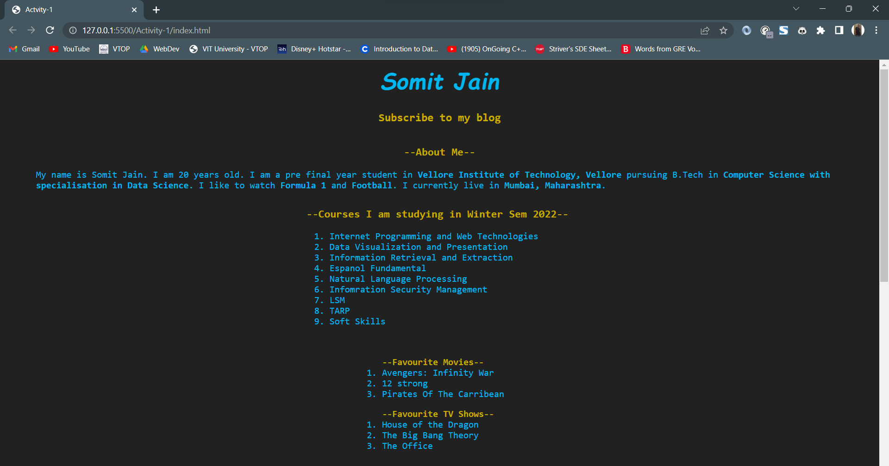

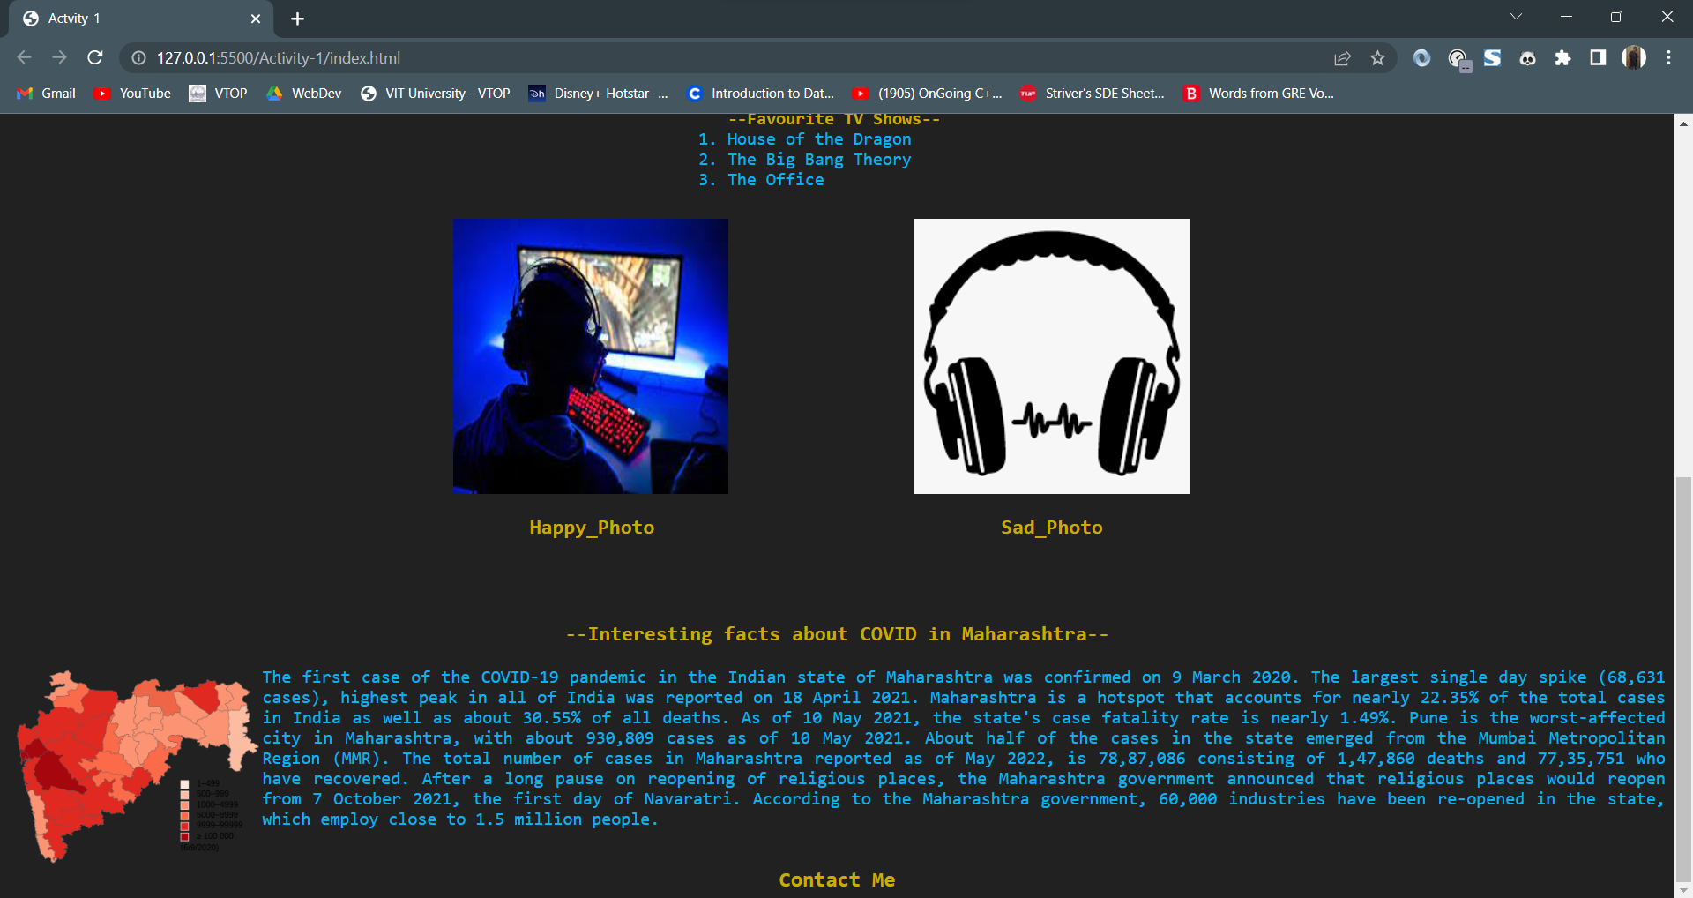

The photo of Maharashtra has image map and is divided into different regions of Maharashtra.

**EMPTY FORM:**

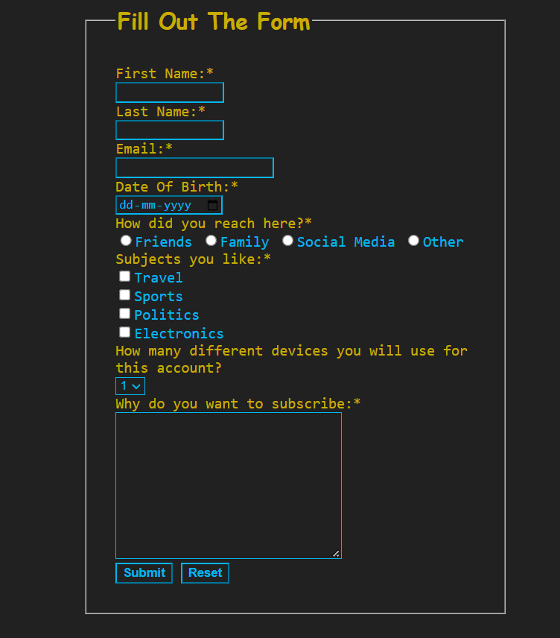

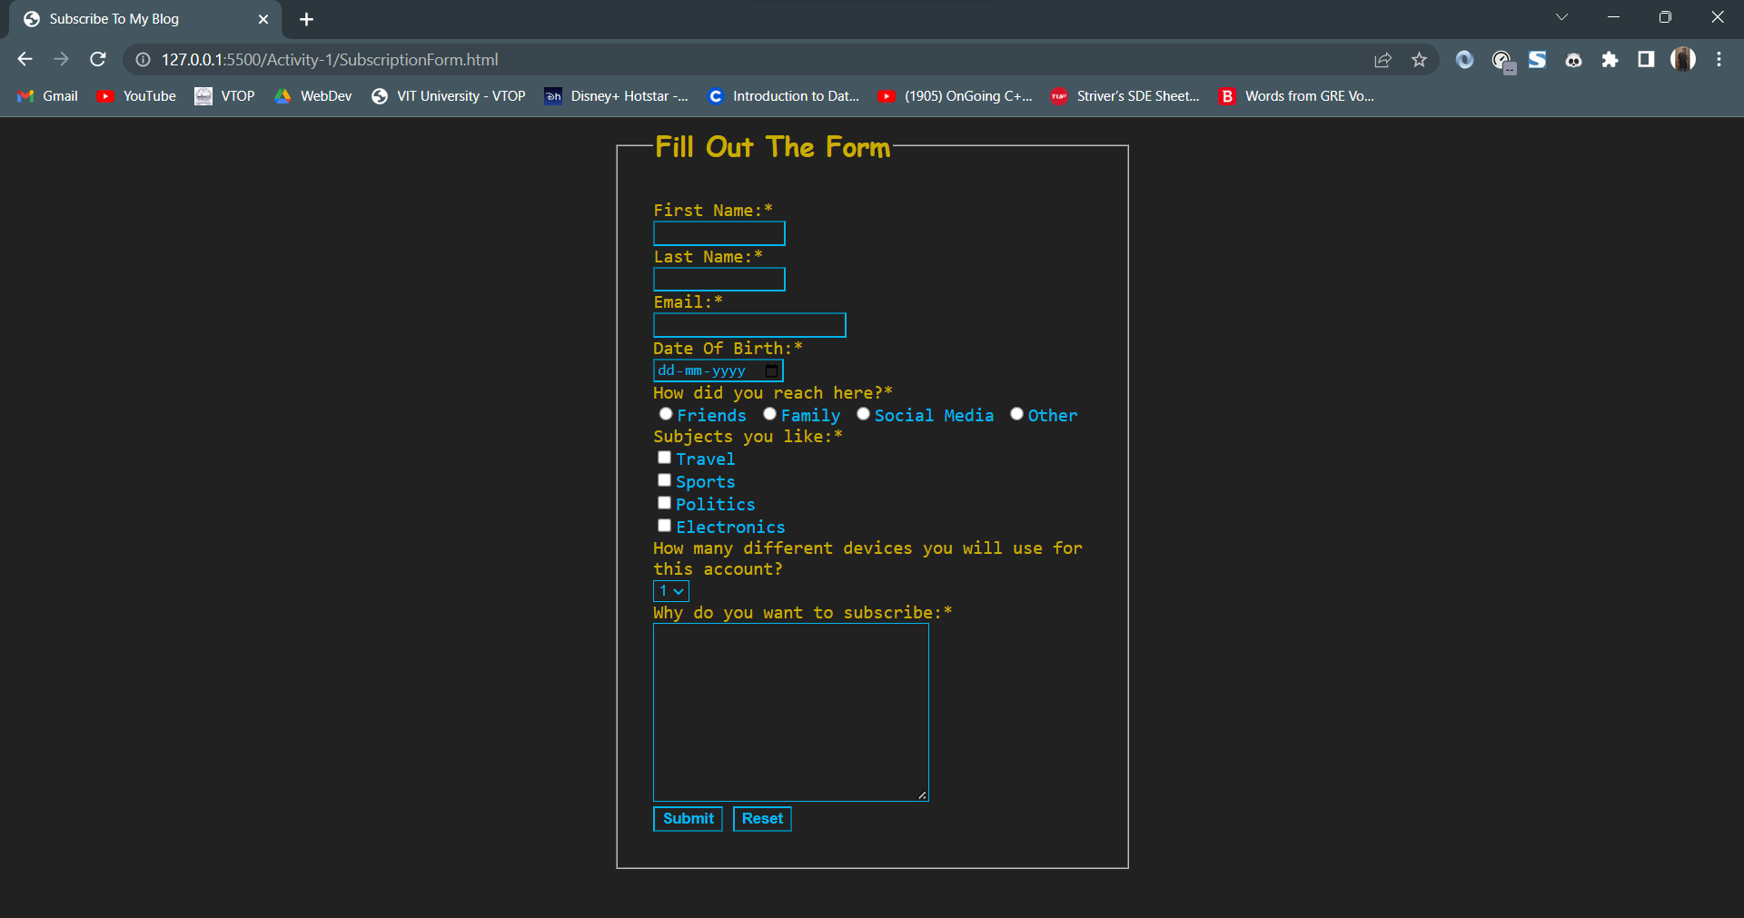

**FILLED FORM:**

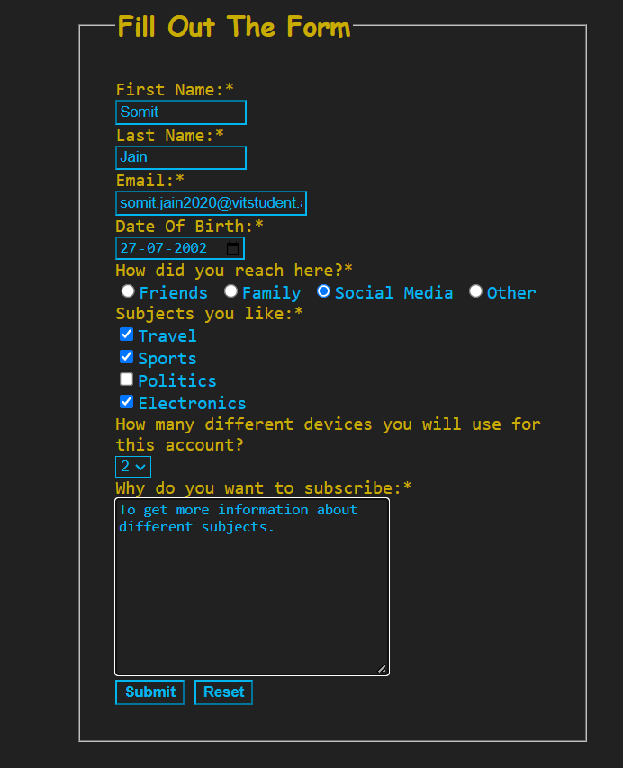

**CONTACT PAGE:**

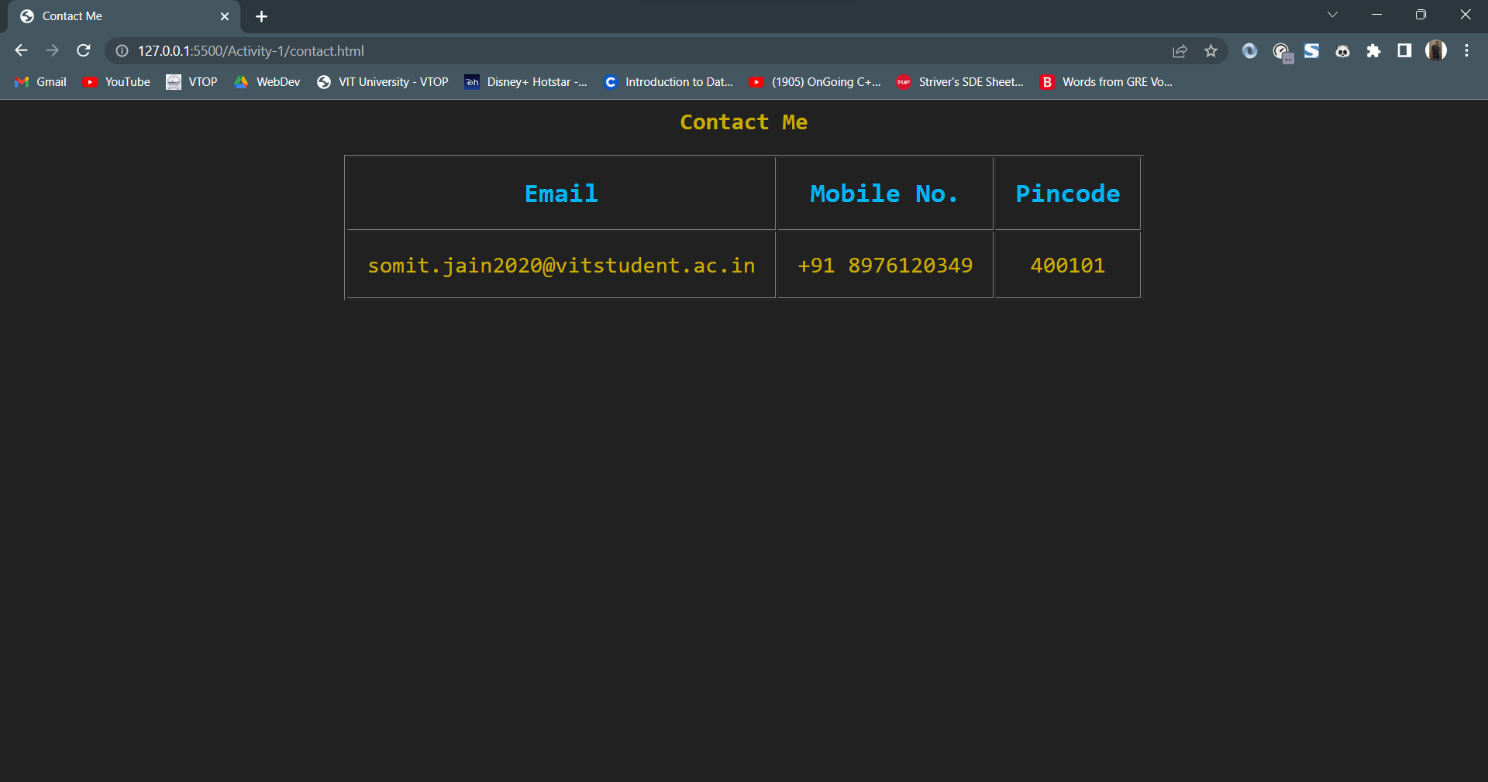

**SCREENSHOTS (WITHOUT CSS):**

**MAIN PAGE:**

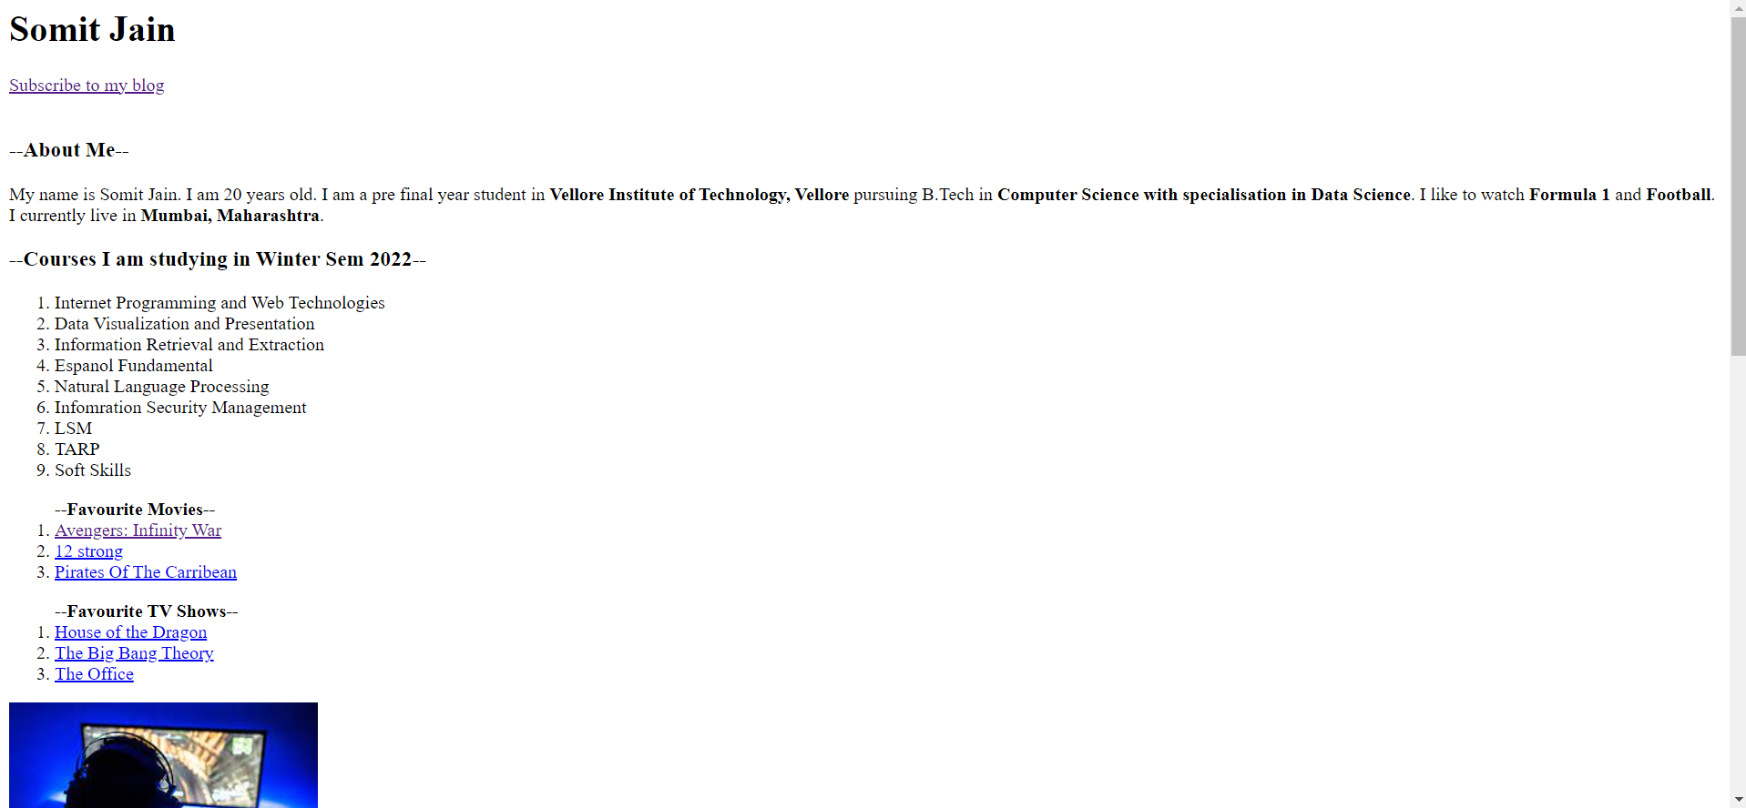

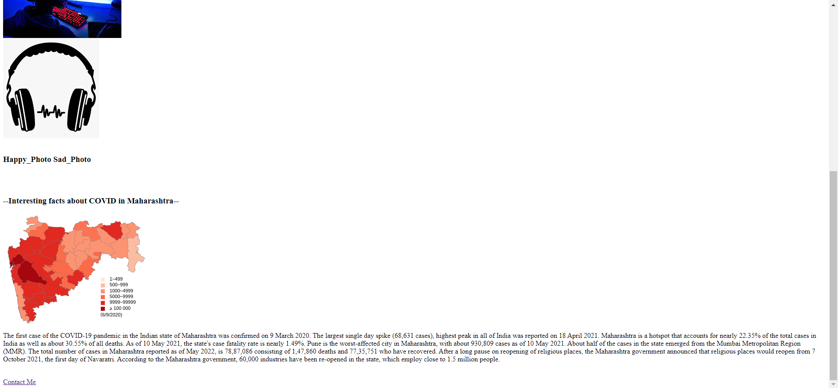

**EMPTY FORM:**

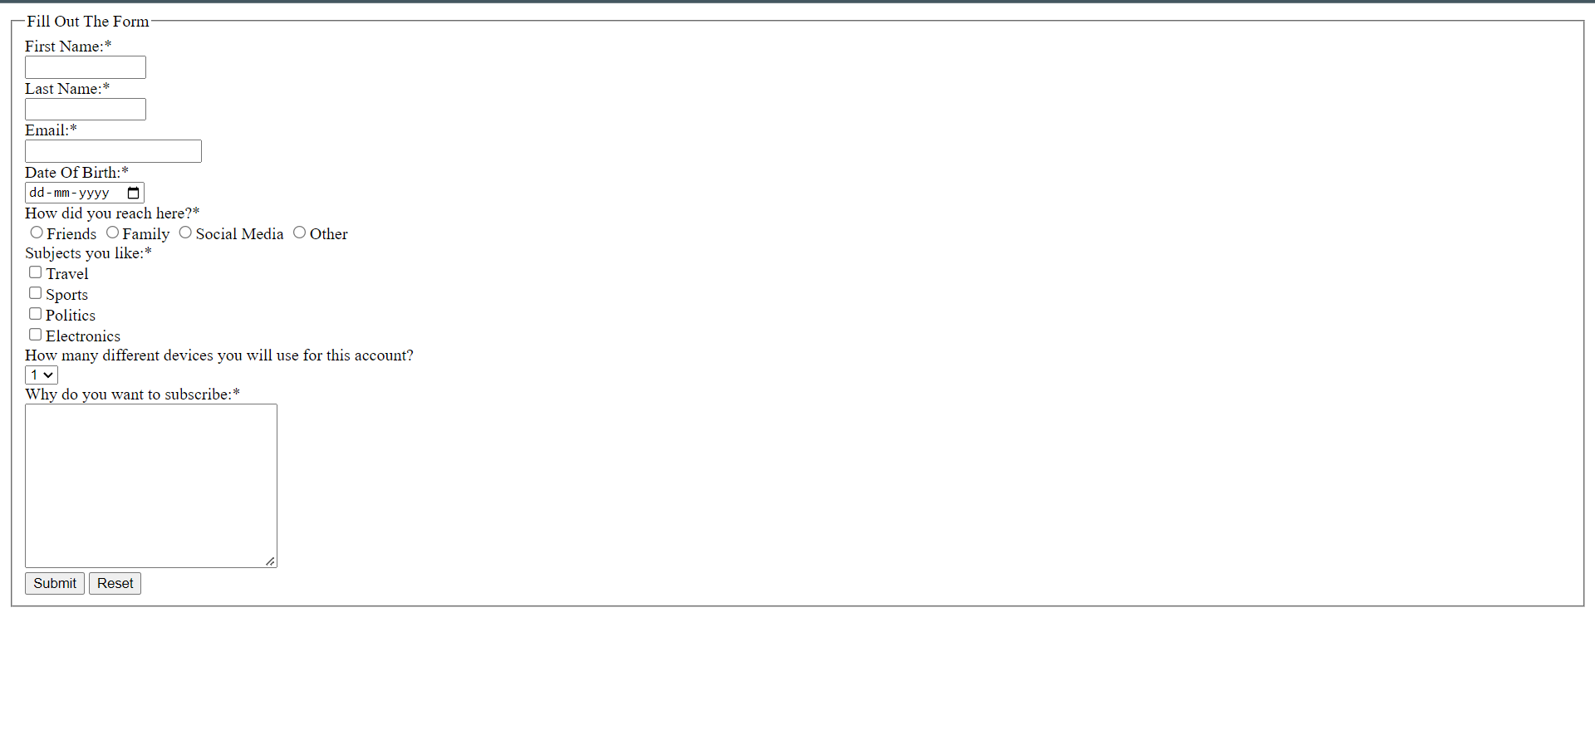

**CONTACT PAGE:**

